Introduction to Algorithm

得失成败尽量置之度外，只求竭尽所能，无愧于心。

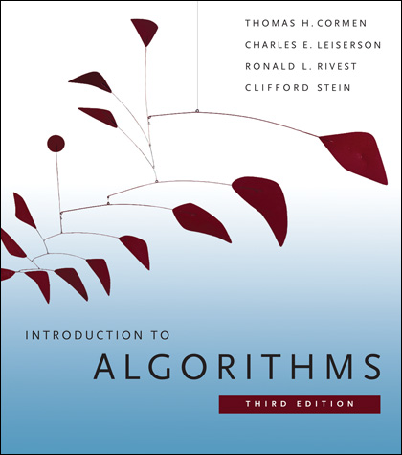

**Merge sort**

Divide-and-conquer method x

merge two sorted arrays x